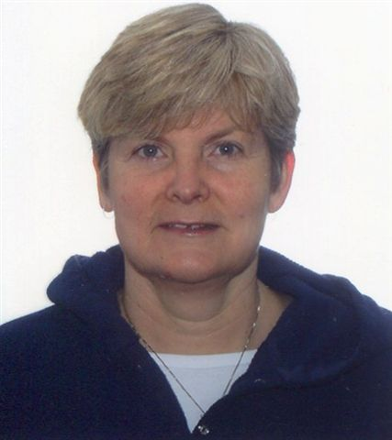

Providing quality care to participants including:

* Helpers
* Handlers
* Dogs (cleared by Vet)
* Officials
* Staff

Services:

* First Response
* Manual Therapy Treatments
* Taping
* Advice and referrals

Aug 17-20, 2022

# Strategies for positive outcomes and injury management for high performance athletes since 1989.

# Combining my love of event coverage and Schutzhund since 2015.

# I will be available (sign up list) at the event, however I would love to hear from you before: contact me with your questions/history at iceandadvice@eastlink.ca

# 

Athletic Therapist and Osteopathic Manual practice

* Heather MacLeod

### @ GSSCC Nationals 2022

(fees are possible for some services)

## Aenean a magna vel pede vestibulum rhoncus. Nulla cursus orci quis tortor.